Task 7: SQL Basics for Data Analytics

1.Show all clients
This query is used to display all the records from the CoreTech business dataset. It shows complete information of all clients, projects, and related details stored in the table. This helps in understanding the full dataset before doing any analysis.

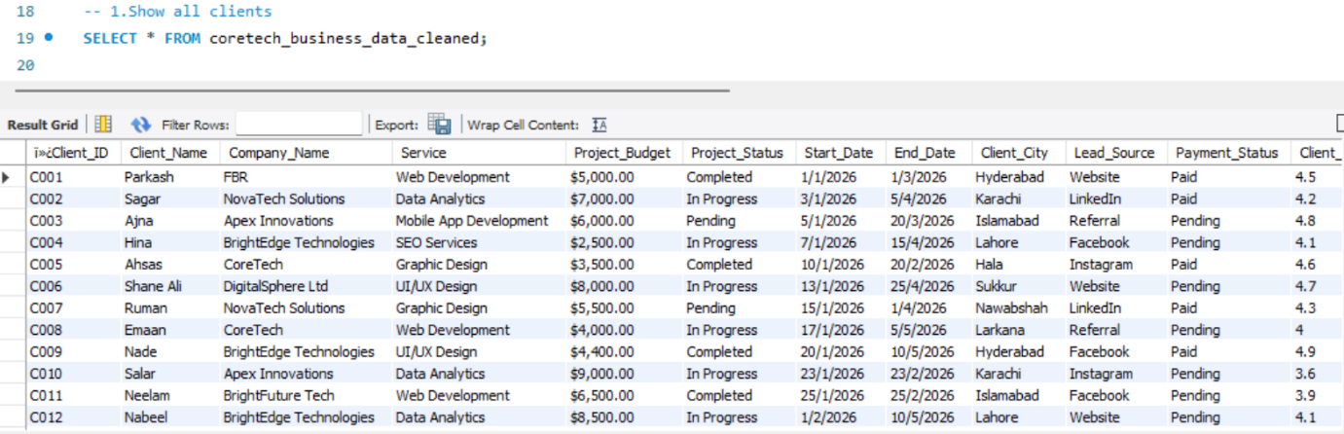

2. Filter by city
This query is used to show only those clients who belong to a specific city like Karachi. It helps to analyze data based on location and understand which cities have more business activity.

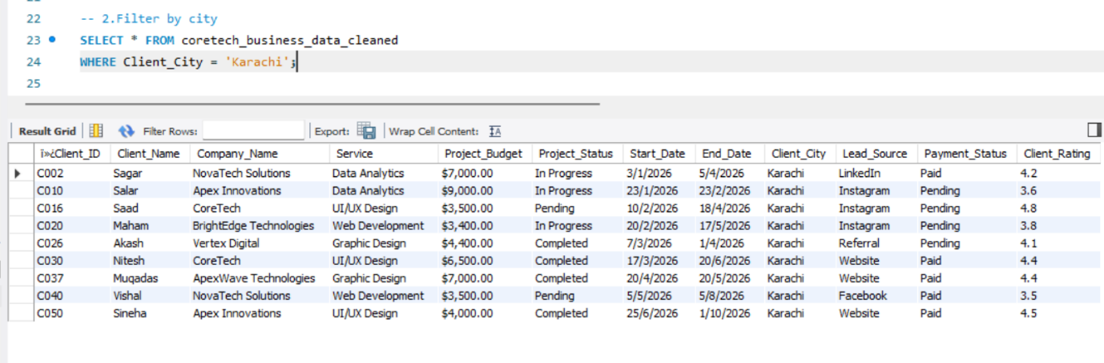

3. Show completed projects
This query retrieves only those projects that have been marked as completed. It helps to track finished work and understand project success rate in the dataset.

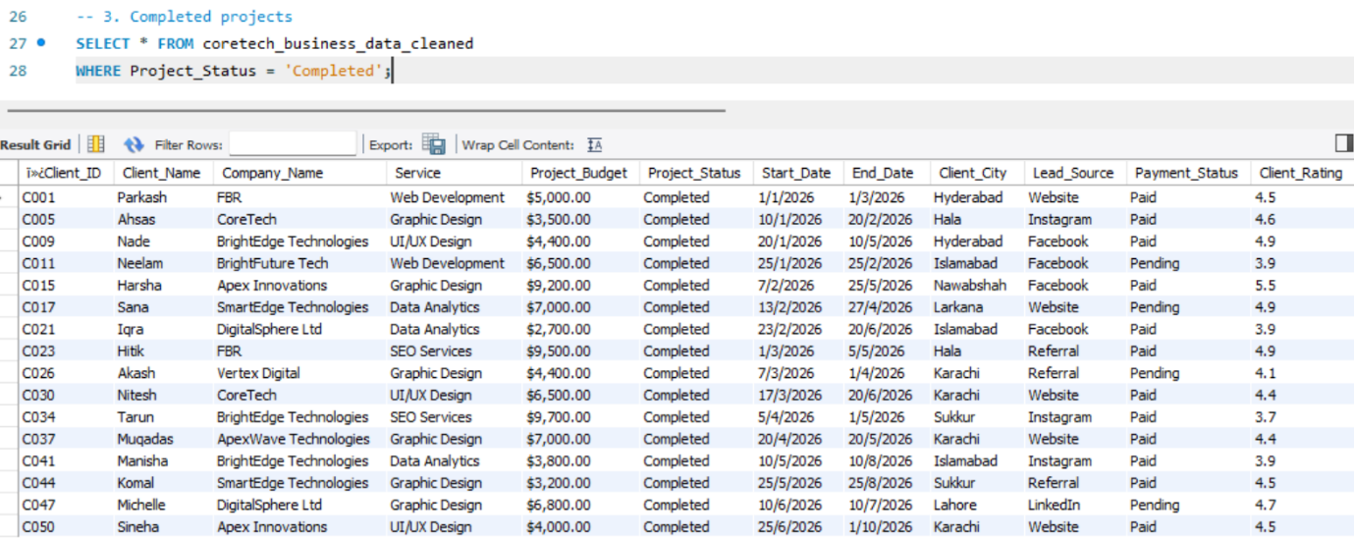

4. Count total clients
This query is used to count the total number of clients present in the dataset. It gives a clear idea of how many records or clients are stored in the system.

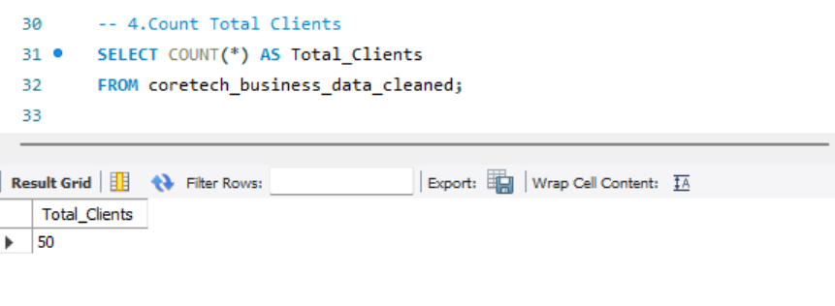

5. Count by service
This query shows the number of clients or projects under each service category. It helps to understand which service is more in demand and which one is less used.

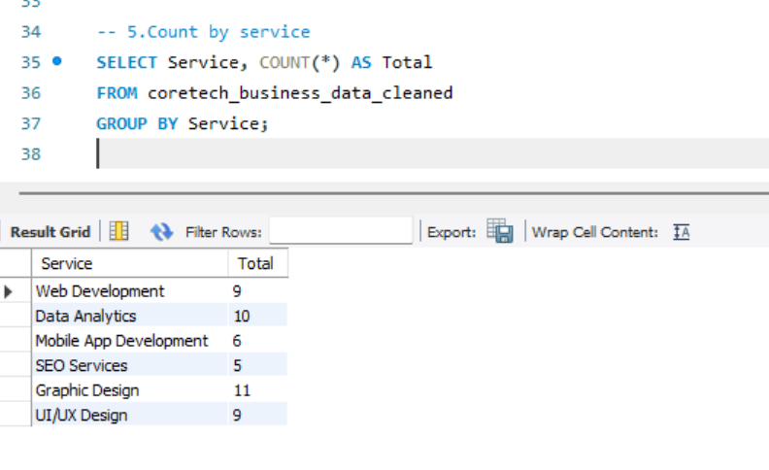
6. Total budget
This query calculates the total budget of all projects combined in the dataset. It represents the overall business value or total revenue generated from all projects.
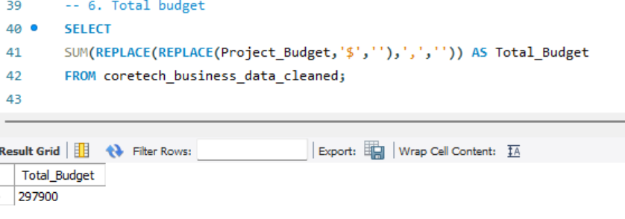

7. Average budget
This query finds the average budget per project. It helps to understand the typical project cost and gives a general idea of budget distribution.
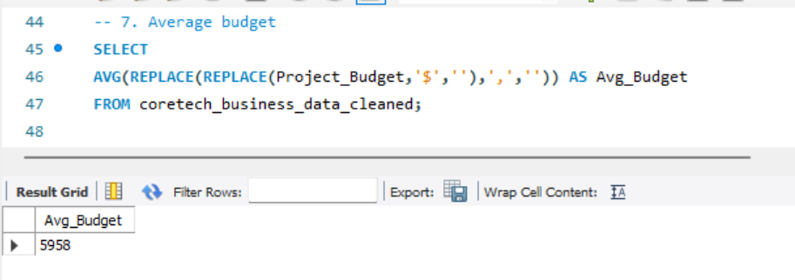

8. Highest budget
This query returns the highest budget value from all projects. It helps to identify the most expensive or high-value project in the dataset.
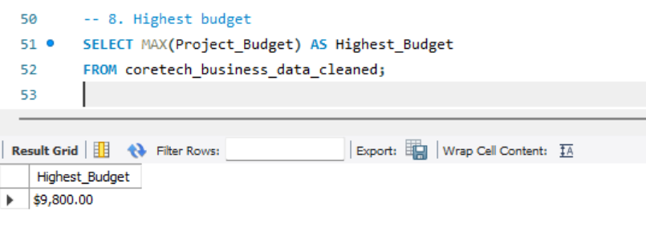
9. Show unpaid projects
This query displays all projects where the payment status is still pending. It is useful for tracking unpaid work and managing financial records.
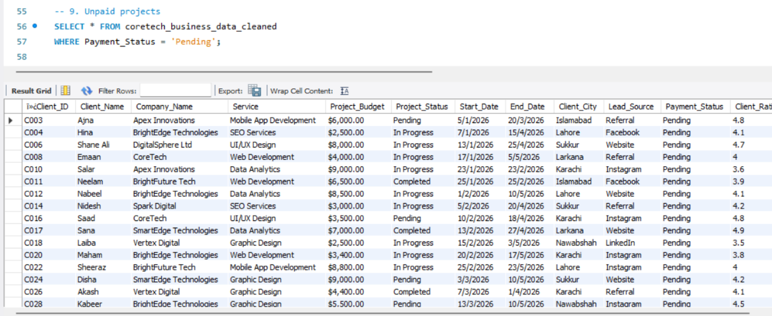

10. Top 5 highest budget projects
This query shows the top 5 projects with the highest budget. It helps to identify the most valuable projects and understand where the highest investment is going.
